# 1.How to create a new console application in GIT?

# ctrl+shift+n

# 2.how to change the plungin?

# tools--> options--->source conrol--->plnin selection.

# 3. how to create a new project in GIT.

# 4. how to configure git repository in local and server.

# 5. Allow multiple Git repositories in a single Team Project

Yes, you can create multiple Git repos per TFS Team Project.

Steps:

1. Open a browser and navigate to the home page for your Git-based team project in TFS

2. From the menu, click on the Code hub as shown below.

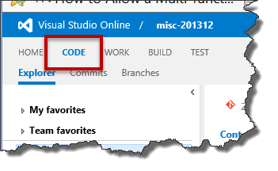

You should now be in the code/source control explorer window.

3. In the right-hand panel, you’ll see the name of the current Git repository.

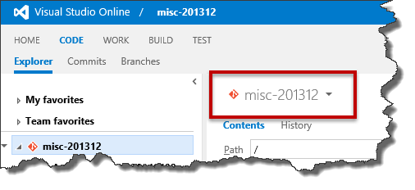

4. Click the “drop down” icon next to the name of the repository to show the repository details.  In this drop down list, you’ll see the list of all the Git repos for your Team Project and at the bottom of this list you’ll see a link that says “Manage repositories…”.  Click the Manage Repositories link.

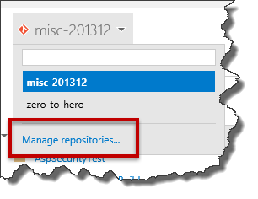

5. You should now see the Version Control control panel for your Team Project.  In the left panel, there’s a button that says “New repository…”.  As you can probably guess, this lets you create a new, additional Git repository for your Team Project.  Click the “New repository…” button.

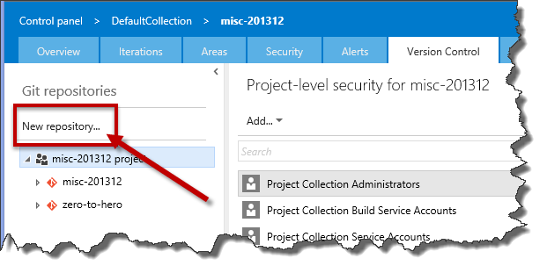

6. You’ll see a dialog with the title “Create a New Git Repository”.  Enter the name of the new repository in the Repository name textbox and click the OK button.

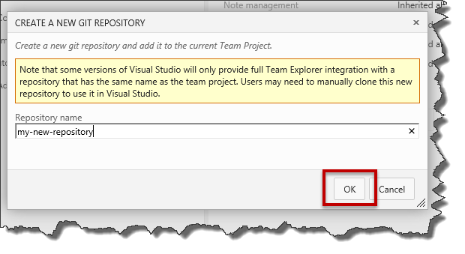

7. Go back to the Code hub’s source control explorer window.  Refresh the web page by clicking your browser’s refresh button.  Now when you pull the repos drop down menu, you’ll see your new Git repository.  Choose the new repository from the drop down menu.

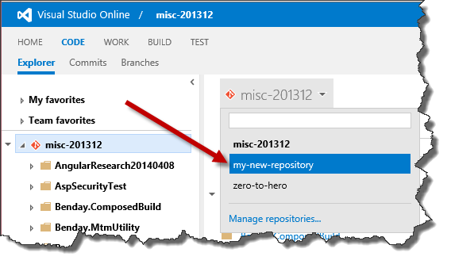

8. You should now see the information about your new empty Git repository along with directions on how to clone this new Git repo to your local machine or to push an existing repository.

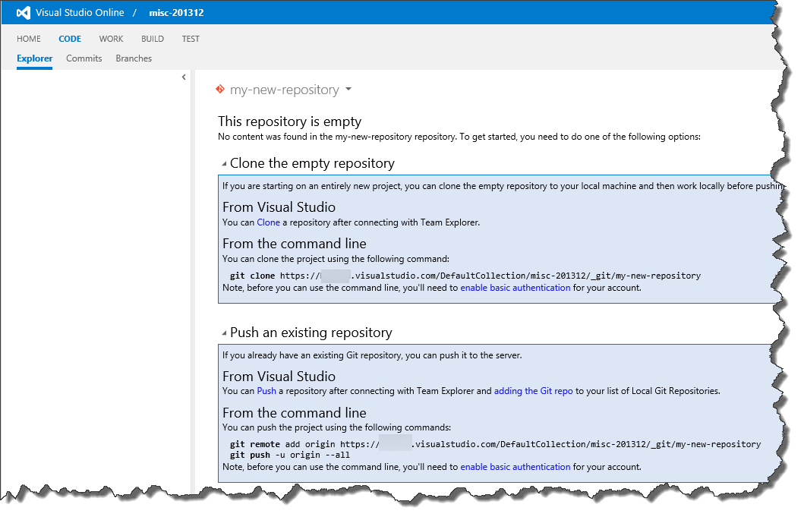

And that’s it.  You’ve created an additional Git repository for your TFS Team Project or Visual Studio Online (VSO) Team Project.